Techno-Commercial Proposal
for MP Cooperative Society Inspection (Nirikshan) Module on ICMIS

MP Cooperative Society — ICMIS Inspection Module (Parakh)



Madhya Pradesh State Electronics  Development Corporation (MPSeDC)  State IT Center, 47-A, Arera Hills,  Bhopal, M.P. – 462011 |  | Prepared for the Office of the Registrar  Cooperative Societies, Government of Madhya Pradesh  Phone: +91-755-2518300  URL: www.mpsedc.mp.gov.in

Techno-Commercial Proposal for New Scope of Work | Document Version 1.2 | October 2026

Contents
Document Control 3
1. Background 4
2. Purpose of this Proposal 4
3. Reference to Existing (Base) System 5
3.1 Existing Components (for reference only) 5
4. Scope of Work 6
5. Functionality List 9
6. Role-wise Access Matrix 10
7. Illustrative Report, Workflow & API Layout 11
7.1 Nirikshan Workflow – Sequence-wise Screens 11
7.2 Illustrative Report, Status and API Layout 16
8. Methodology & Approach 18
9. Deliverables 18
10. Project Timeline 19
11. Resource & Cost Estimate 20
12. Payment Terms 21
13. Assumptions & Constraints 21
14. Reference Documents 22
15. Contact Persons 22

Document Control
Field | Value
Document Title | MP Cooperative Society ICMIS Inspection (Nirikshan) Module – Techno-Commercial Proposal for New Scope of Work
Base Document | Business Specification – Nirikshan Module v1.0 (May 2026); Previous shared Nirikshan form on 30.07.2026, Approved Final Nirikshan Form, RCS IT Section, 02.10.2026
Prepared For | Office of the Registrar Cooperative Societies (RCS), Co-operation Department, Govt. of Madhya Pradesh
Prepared By | MPSeDC — Parakh Team / Business Analysis
Trigger References | RCS IT Section email dated 10.09.2026 (Updated Inspection Format & Master Data); RCS Computerization Meeting dated 18.09.2026; Updated Nirikshan Form dated 02.10.2026; Department requirement note (Inspection Report, e-Sign, Login, User List, ICMIS API)
Version | 1.2
Status | Submitted for Approval
Classification | Commercial in Confidence

1. Background
The Office of the Registrar Cooperative Societies (RCS), Madhya Pradesh, is computerizing the annual inspection (Nirikshan) of Co-operation Department offices through the Integrated Cooperative Management Information System (ICMIS) portal and the Parakh platform. The business process, roles, workflow and report structure have been captured in the Business Specifications for the Nirikshan Module, previously shared Nirikshan form on 30.07.2026, and the approved final format of the Nirikshan Form was shared by the RCS IT Section on 02.10.2026.
Since then the Department has issued an updated Nirikshan Form and Master Data (10.09.2026; updated form dated 02.10.2026), shared UAT feedback, and, following the RCS Computerization Meeting of 18.09.2026, communicated a further set of requirements: an Inspection Report view in the ICMIS Departmental Login, a Custom e-Sign facility, an ICMIS-style Department-only login page, a hierarchy-wise user listing with search, and an API to share inspection reports with ICMIS. The Department has also defined the rules for annual roster creation and assignment among Joint, Deputy and Additional Registrar offices.
The Nirikshan workflow in brief (UAT screens are shown sequence-wise in Section 7.1):
- The Commissioner opens the Roster List, adds a new roster and allots Division / District / Divisional offices to the surveyors (inspecting officers), then saves the record.
- The Commissioner proceeds to eSign & Schedule: an inspection remark is entered and the order is signed on the MP eSign portal using Aadhaar OTP authentication; the inspection is then scheduled.
- The surveyor sees the office in the Assigned Inspection List with the order number and office order copy, and uses the Fill action to open the Nirikshan Prativedan.
- The surveyor fills the Nirikshan Prativedan, divided into section-wise tabs with progress tracking, then submits it; the report can be printed and viewed from the ICMIS portal.
- The Commissioner / Nodal Officer reviews completed inspections in View Inspection (summary analysis, Excel export and report view) and, in future, in the Inspection Report tab of the ICMIS Departmental Login.
Note: This proposal covers the new scope of work shared by the Department, including the development of the Nirikshan form and the end-to-end inspection workflow. Screens already available on Parakh in UAT are referenced for context in Section 3 and Section 7.1.

2. Purpose of this Proposal
This proposal defines the functional scope, delivery approach, timeline and cost for the new scope of work for the MP Cooperative Inspection Module. The scope is arranged in the sequence in which the inspection workflow runs: (1) masters and user data preparation (RCS Office master & User Template), (2) ICMIS-style Department login page & UI (customize Parakh login page), (3) hierarchy-wise user listing (JR, DR, AR), (4) annual roster and inspection order management, (5) Custom e-Sign through MP eSign, (6) complete module developed in Parakh needs to be re-designed according to ICMIS portal User Interface(UI), (7) development of the end-to-end inspection workflow, and status tracking, (8) Nirikshan Prativedan form development (new format), (9) filteration with keyword search, (10) publishing inspection reports in the ICMIS Departmental Login, report view, & dashboards, and (11) API integration to share signed reports with ICMIS.
The intended outcomes are:
- A fully digital annual inspection cycle, from roster and signed order to the submitted inspection report.
- Accountability through role-based access, e-signed orders and reports.
- Monitoring of inspections by the Commissioner and Nodal Officers, with status, pending days, overdue alerts and downloadable reports.
- Inspection reports made available to departmental officers in the ICMIS portal and shared with ICMIS through an API.

3. Base & Enhancement System
The Parakh platform already provides the screens listed below in the UAT environment, as shown in the screenshots shared by the project team (test data). They form the base on which the new scope of work in Section 4 is delivered. Field-level specification of the form and the process is documented and the Updated Nirikshan Form.

3.1 Components
S.No. | Component | Current Status
1 | Roster List (Commissioner login) | Order number, status, created dates, schedule dates, remark, total assigned / pending / ongoing / completed counts, order copy, Add New
2 | Add Roster (office and surveyor allotment) | Office Type, Division, District, Office Name, Surveyor; Save, Edit, Delete
3 | eSign & Schedule through MP eSign | Remark entry and redirection to MP eSign (Aadhaar OTP)
4 | Assigned Inspection List (Surveyor login) | Order details, schedule date, status, remarks, office order, Fill action
5 | Nirikshan Prativedan form | Section-wise tabs with progress, Print and Save & Next; Section (A) basic details auto-filled; till Section (M)
6 | View Inspection (summary analysis) | Screen available with data; Excel export and View Report actions
7 | Master (Designation, User), User List, Circular/Notification, Reset Password | RCS Office master, User list hierarchy-order and has Office Name
8 | Parakh login page; hand-off of reports to ICMIS | Use ICMIS design for Login Page; hand-off to ICMIS
Reference: The approved Nirikshan Form (30.07.2026) and the Updated Nirikshan Form (02.10.2026) for the complete section structure.

4. Scope of Work
The following items are in scope, as per the Department’s requirement note, the updated Nirikshan Form and the UAT feedback received. They are arranged in the sequence of the Nirikshan workflow:

SOW-01: Masters & Data Preparation
- Inspection Officer (surveyor) master from existing ICMIS / e-HRMS data, Office master, Office Head master and Designation master as confirmed by the Department.
- Master mapping for “Auto” fields and dependent drop-downs, for example the number of registered Urban Cooperative Banks in a district (Section H).
- Bulk creation of users from the Department’s User List template (First/Last name, Designation, Role, Reporting Officer, District).

SOW-02: Login Page – Department Option Only
- Provide the Parakh login page in the ICMIS portal design format (colour theme, layout, captcha and OTP flow).
- Display only the “Department” login option; other options are removed/not displayed.
- Align module UI colours with the ICMIS portal (UAT observation: UI colour mismatch between Parakh and ICMIS).

SOW-03: Hierarchy-wise User Listing with Search
- Display users in the order: JR (Joint Registrar) first, then DR (Deputy Registrar), then AR (Additional Registrar).
- Provide a keyword-based search to quickly locate a particular user.
- Provide the “Office Name” (कार्यालय का नाम) field in the User Master.

SOW-04: Annual Inspection Roster & Order Management
- Commissioner creates the annual inspection roster from the Roster List (Add New): row-wise selection of Office Type, Division, District and Office Name, allotment of the Surveyor from the searchable officer list, with Add / Edit / Delete and Save before scheduling.
- Eligibility rules: AR – only AR offices; DR – AR and DR offices; JR – JR, DR and AR offices. An officer is not offered his/her own office, and an office assigned once in a year is removed from the list for other officers (one inspection per office per year; multiple offices per officer allowed).
- An inspector allotted to a Deputy Commissioner office is also allotted the Assistant Commissioner (Audit) and (Administration) offices, as per the inspection order.
- Roster status lifecycle (Draft, Schedule, In-Progress) with Total Assigned / Pending / Ongoing / Completed counts and the signed order copy against each roster; order number in the form 2026/ICMIS-RCS/0000n.
- On scheduling, the signed order is dispatched to the surveyors concerned by email and portal notification, with the order number and roster list.

SOW-05: Custom e-Sign Facility (MP eSign)
- Provide a Custom e-Sign facility so authorized users can digitally sign the annual inspection order (Commissioner) and the inspection report (Surveyor) as per the prescribed workflow.
- Integration with the MP eSign (Hastakshar) Gateway: the inspection remark is captured, the document is prepared and the user is redirected for Aadhaar e-KYC consent and OTP authentication; the signed PDF is returned to Parakh.
- Signed PDF carries signer name, designation and timestamp; every e-sign event is written to an audit log with IP address.
- A signed document cannot be edited; changes are handled through a separate Corrigendum (शुद्धिपत्र) process.

SOW-06: Inspection Workflow, Status Tracking & Notifications
- End-to-end workflow in four phases: (A) Order issuance, (B) Pre-inspection acknowledgement and “Start Inspection”, (C) Report filling, (D) e-Sign and submission, followed by review by the Commissioner / Nodal Officer.
- Surveyor login: Assigned Inspection List with order number, office details, schedule date, status, inspection / submission remark, office order copy and the Fill action; start date/time of inspection is logged.
- Status lifecycle: Order Issued → In Progress → Completed, with Overdue flagged automatically by a daily batch after the deadline (current-year reports by 5th April; previous-year pending reports by 31st December).
- Email and portal notifications at order dispatch, report completion and overdue alerts; Circular/Notification menu retained.

SOW-07: Nirikshan Prativedan (Inspection Report) Form Development
- Develop the digital Nirikshan Prativedan form as per the Updated Nirikshan Form (02.10.2026), covering the report sections defined in the BSD, organized into section-wise tabs (13 sections) with progress indicator and status overview: office and inspection details, establishment, accounts / budget, registration, elections, inspection, liquidation, urban credit societies, complaints, audit, court cases and related sections.
- Basic details are auto-filled and locked from the roster order and login: Inspecting Officer Name, Office to be Inspected and Inspection Date; Office Head Name is picked from the master; District Name is auto-filled in the audit tables.
- Tab-wise Save & Next with sub-sections; “Add Row” provided only where explicitly specified in the format, with tabular alignment and visible scroll bars.
- Auto-calculated fields as per the format: Vacant = Sanctioned − Filled, Pending = A − B, Total = A + B, Recovery % = F / C × 100; validation that Filled + Vacant = Sanctioned.
- Drop-downs from masters: Designation Master in the setup tables and the list of Sections (e.g. 84, 64, 58B) in the recovery-case and court-case tables.
- Pre-fill of available data from ICMIS (society counts, registration status, audit fee), eHRM (attendance) and CJCMS (court cases), where the respective APIs are made available; user can verify and update.
- Draft save at any time (auto-save every 5 minutes), mandatory remarks field per section for analytical observations, and Preview Report with incomplete sections flagged.
- Final Submit with mandatory-field validation, followed by OTP e-Sign (SOW-05) and generation of the signed Nirikshan Prativedan PDF containing all sections, e-signature details and office letterhead; Print available from the ICMIS portal.
- UAT feedback incorporated: Election section text correction, audit section recovery-case sections with Section drop-down, court cases section, and ICMIS-aligned UI colours.

SOW-08: Inspection Report View, Dashboards & Departmental Login Tab
- Provide a separate “Inspection Report” tab/menu in the ICMIS Departmental Login so authorized departmental officers can view and download submitted inspection reports, with filters for Year, Office Name and Status. Marked as a priority item by the Department.
- Surveyor View Inspection: list of inspections submitted by the surveyor, with view and print.
- Commissioner / Nodal Officer View Inspection: summary analysis of completed inspections with search, Excel export and View Report per office.
- Dashboards: total offices assigned, completed, in progress, yet to start, overdue and average days to complete; roster status report with Year and Roster Date filters, pending days and PDF / Excel download; office-level dashboard with Year, Office and Status filters and major issues for completed reports.

SOW-09: API Integration with ICMIS for Sharing Inspection Reports
- Develop an API to share signed inspection reports with ICMIS.
- Basic payload parameters: Officer ID, Officer Name, Designation, Office ID, User ID and Inspection Report PDF.
- Additional parameters can be added based on further discussion with the receiving (ICMIS) team.
- Secure authentication, request/response logging, retry handling and error reporting for failed transfers.

5. Functionality List
S.No. | Functionality | Reference | Workflow Stage
1 | Masters and user data preparation | SOW-01 | Foundation
2 | ICMIS-style login page, Department option only | SOW-02 | Access
3 | Hierarchy-wise user listing (JR → DR → AR) with keyword search | SOW-03 | Access / Users
4 | Annual roster and inspection order management | SOW-04 | Phase A – Roster
5 | Custom e-Sign through MP eSign (orders and reports) | SOW-05 | Phase A / D – Signing
6 | Inspection workflow, status tracking and notifications | SOW-06 | Phase B – Inspection
7 | Nirikshan Prativedan form development | SOW-07 | Phase C / D – Report
8 | Inspection report view, dashboards and Departmental Login tab | SOW-08 | Review / Monitoring
9 | API integration with ICMIS for inspection reports | SOW-09 | Integration

6. Role-wise Access Matrix
Functionality | Commissioner (State Admin) | Nodal Officer | Surveyor (Nirikshankarta)
Create roster; allot offices to surveyors; eSign & Schedule | Yes (MP eSign) | – | –
View assigned inspection; download order; Fill form | – | View | Yes (assigned offices)
Save draft, preview, Final Submit and e-Sign report | – | – | Yes (MP eSign)
View Inspection, summary analysis, Excel / PDF download | Yes (all) | Yes (division) | Own submitted reports
Inspection Report tab in ICMIS Departmental Login | Yes (all) | Yes | Own reports
Overdue alerts and notifications | Yes | Yes | Yes
Hierarchy-wise user list and search | Yes | Yes | –
API push of signed report to ICMIS | System-triggered | System-triggered | System-triggered
Note: Inspection eligibility follows the rule JR → JR/DR/AR offices, DR → DR/AR offices, AR → AR offices. No officer may be assigned his/her own office (Section 4, SOW-04).

7. Illustrative Report, Workflow & API Layout

7.1 Nirikshan Workflow – Sequence-wise UAT Screens
The table and screens below show the MP Cooperative Nirikshan workflow step by step, as available on Parakh in the UAT environment (test data). Each step is mapped to the relevant scope of work.
Step | Screen | Actor | Scope
1 | Roster List (Commissioner) | Commissioner / State Admin | SOW-04
2 | Add Roster – allot offices to the surveyor | Commissioner / State Admin | SOW-04
3 | Save roster record | Commissioner / State Admin | SOW-04
4 | eSign & Schedule – inspection remark | Commissioner / State Admin | SOW-05
5 | Connecting to MP eSign | System | SOW-05
6 | MP eSign (Hastakshar) – consent | Commissioner / State Admin | SOW-05
7 | Assigned Inspection List (Surveyor) | Surveyor / Nirikshankarta | SOW-06
8 | Nirikshan Prativedan form – section-wise tabs | Surveyor / Nirikshankarta | SOW-07
9 | View Inspection (Surveyor) | Surveyor / Nirikshankarta | SOW-08
10 | View Inspection – summary analysis (Commissioner) | Commissioner / Nodal Officer | SOW-08

Step 1: Roster List (Commissioner) — SOW-04
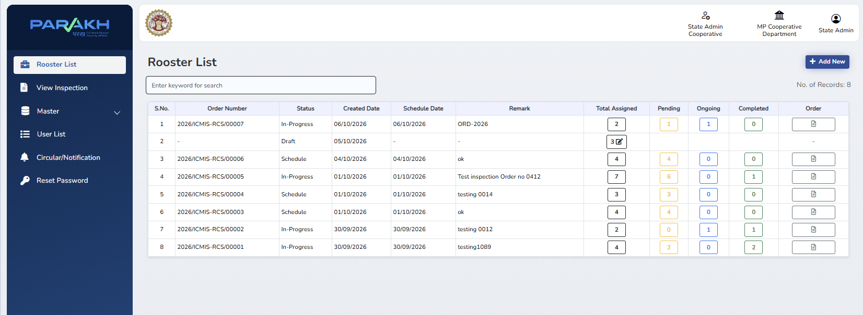
Roster List shows existing rosters with order number, status (Draft / Schedule / In-Progress), created and schedule date, remark and Total / Pending / Ongoing / Completed counts. “Add New” starts a new roster.
Step 2: Add Roster – allot offices to the surveyor — SOW-04
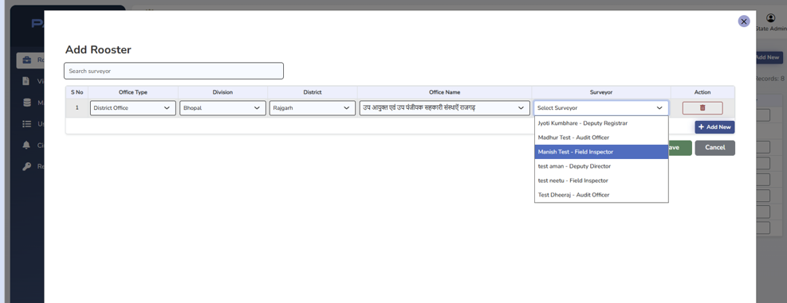
Office Type, Division, District and Office Name are selected row-wise and a Surveyor (inspecting officer) is allotted from the searchable list; rows can be added or deleted.
Step 3: Save roster record — SOW-04
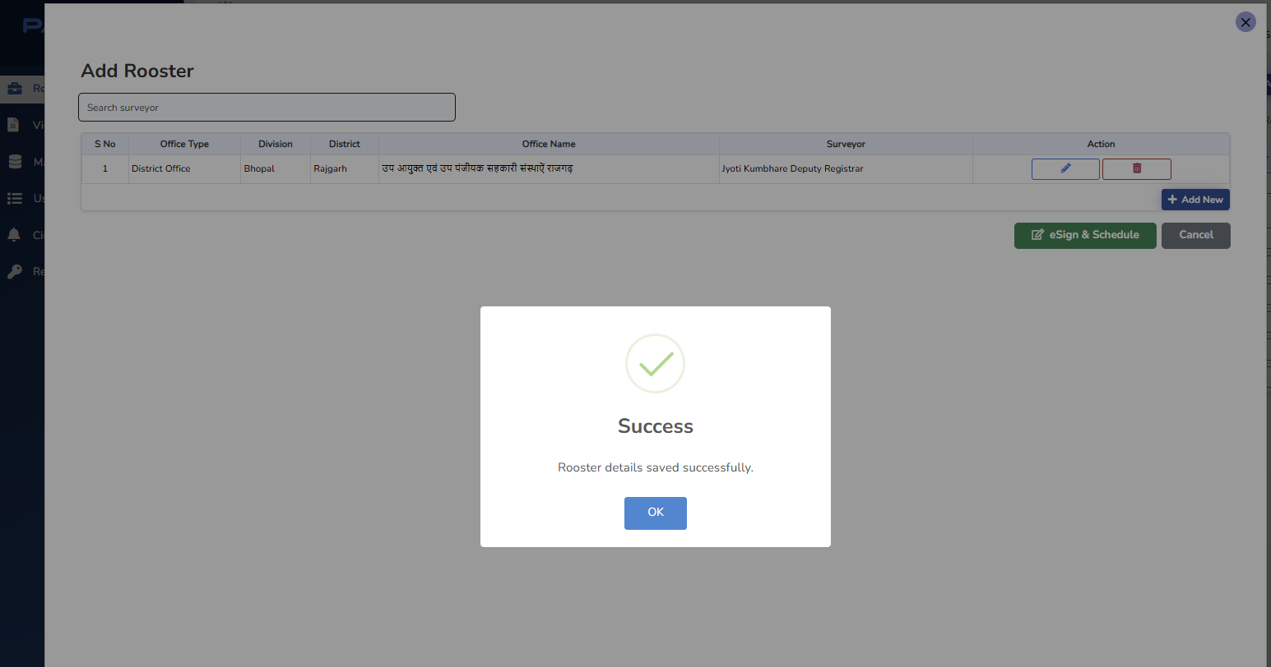
Roster details are saved; rows can still be edited or deleted. “eSign & Schedule” moves the roster to signing and scheduling.
Step 4: eSign & Schedule – inspection remark — SOW-05
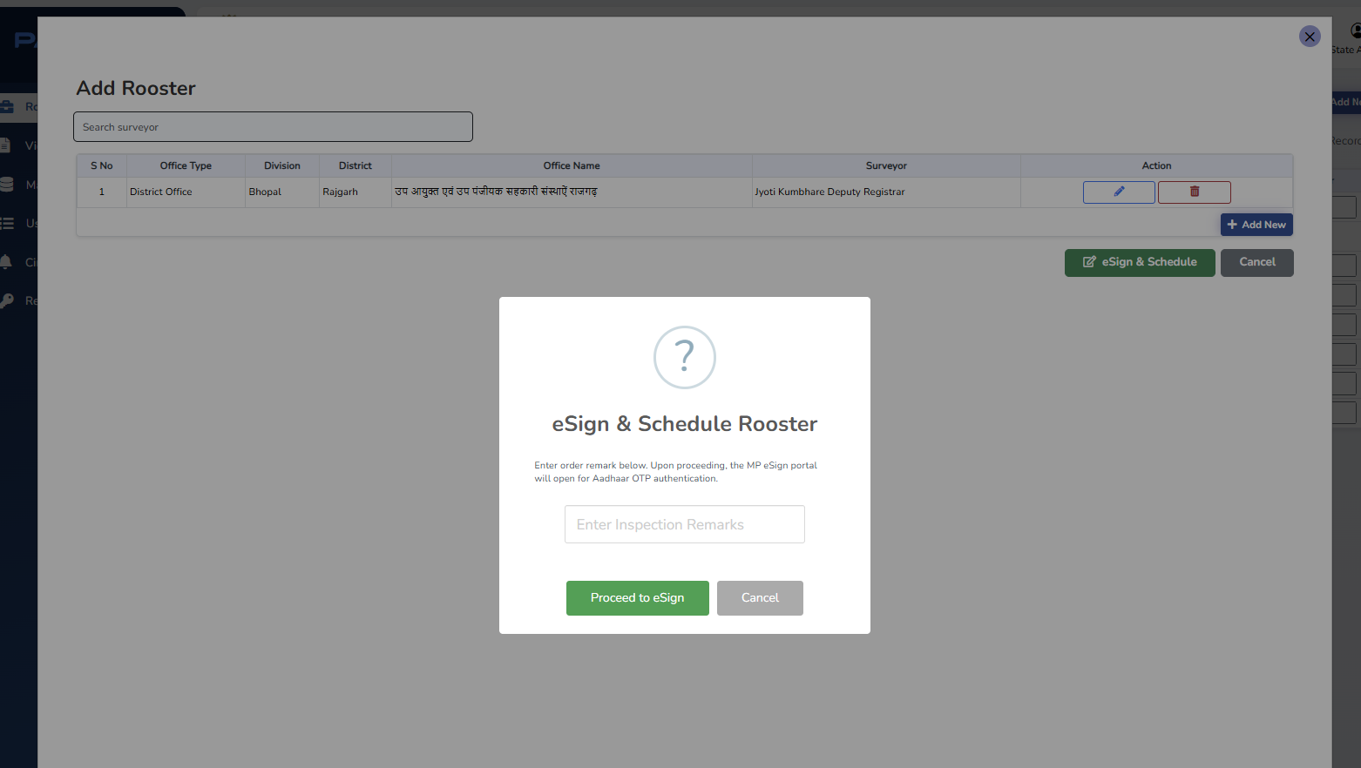
The Commissioner enters the inspection order remark; on proceeding, the MP eSign portal opens for Aadhaar OTP authentication.
Step 5: Connecting to MP eSign — SOW-05
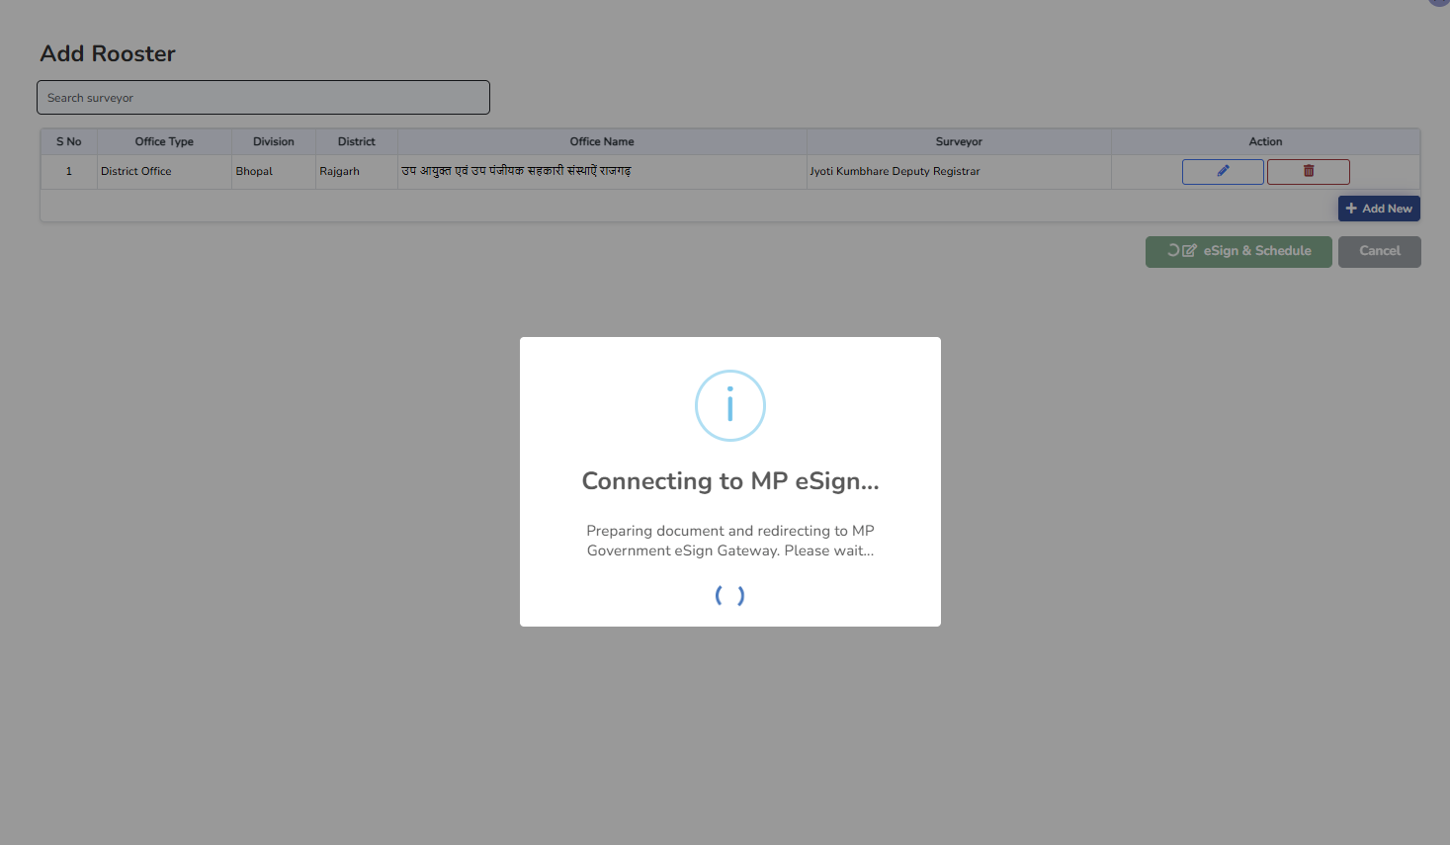
The order document is prepared and the user is redirected to the MP Government eSign Gateway.
Step 6: MP eSign (Hastakshar) – consent — SOW-05
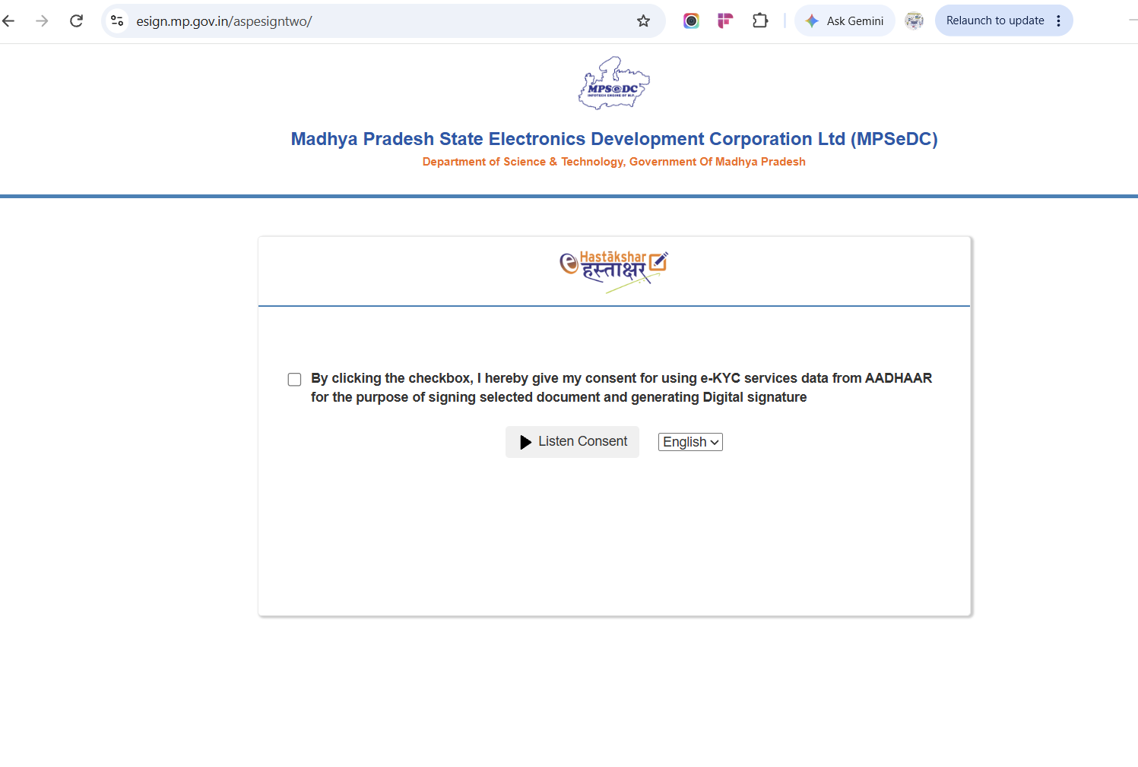
Aadhaar e-KYC consent screen of the MP eSign service; the signed order is returned to Parakh and the roster becomes scheduled.
Step 7: Assigned Inspection List (Surveyor) — SOW-06
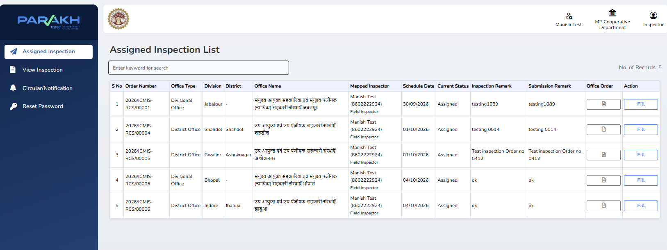
The surveyor sees assigned offices with order number, office type, division, district, schedule date, status, remarks, office order copy and the “Fill” action for the Nirikshan Prativedan.
Step 8: Nirikshan Prativedan form – section-wise tabs — SOW-07
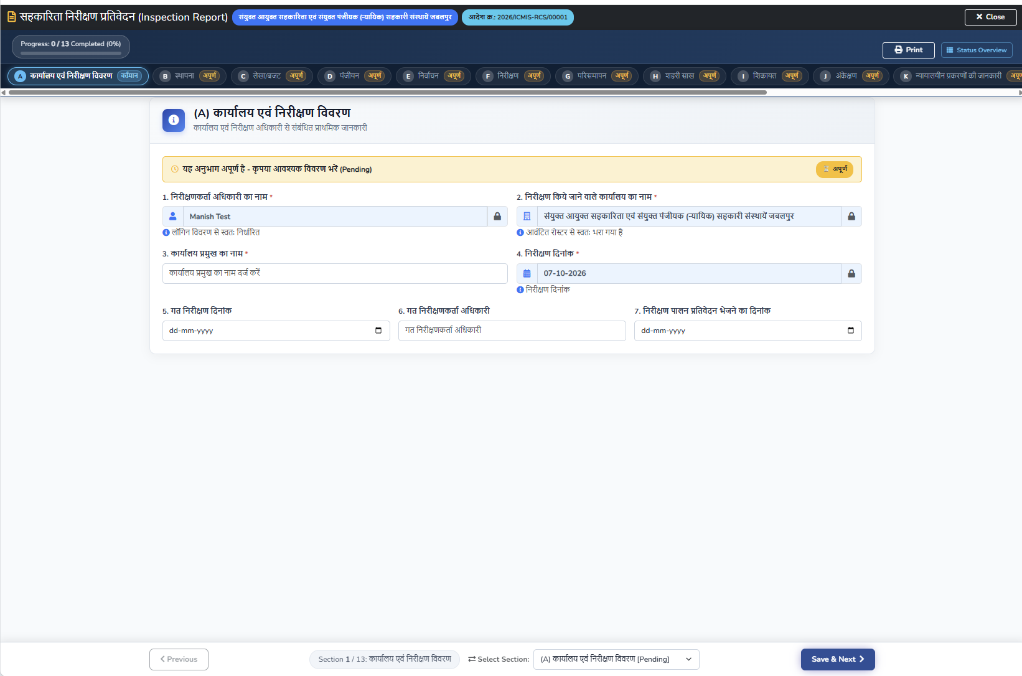
The report is divided into section tabs (A, B, C …) with progress indicator, status overview, Print, Previous and Save & Next. Inspector, office and date are auto-filled and locked.
Step 9: View Inspection (Surveyor) — SOW-08
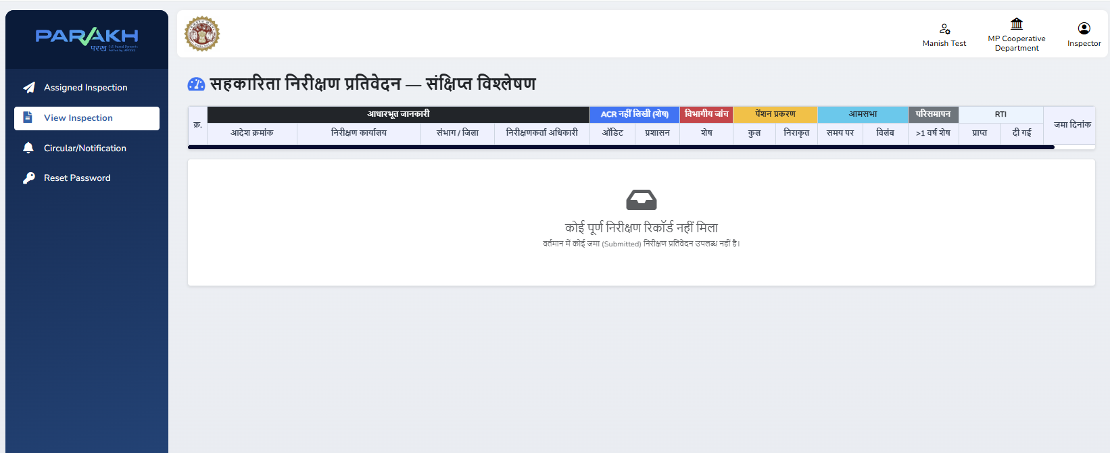
After submission, the surveyor can print the report from the ICMIS portal and view the inspections submitted by him/her.
Step 10: View Inspection – summary analysis (Commissioner) — SOW-08
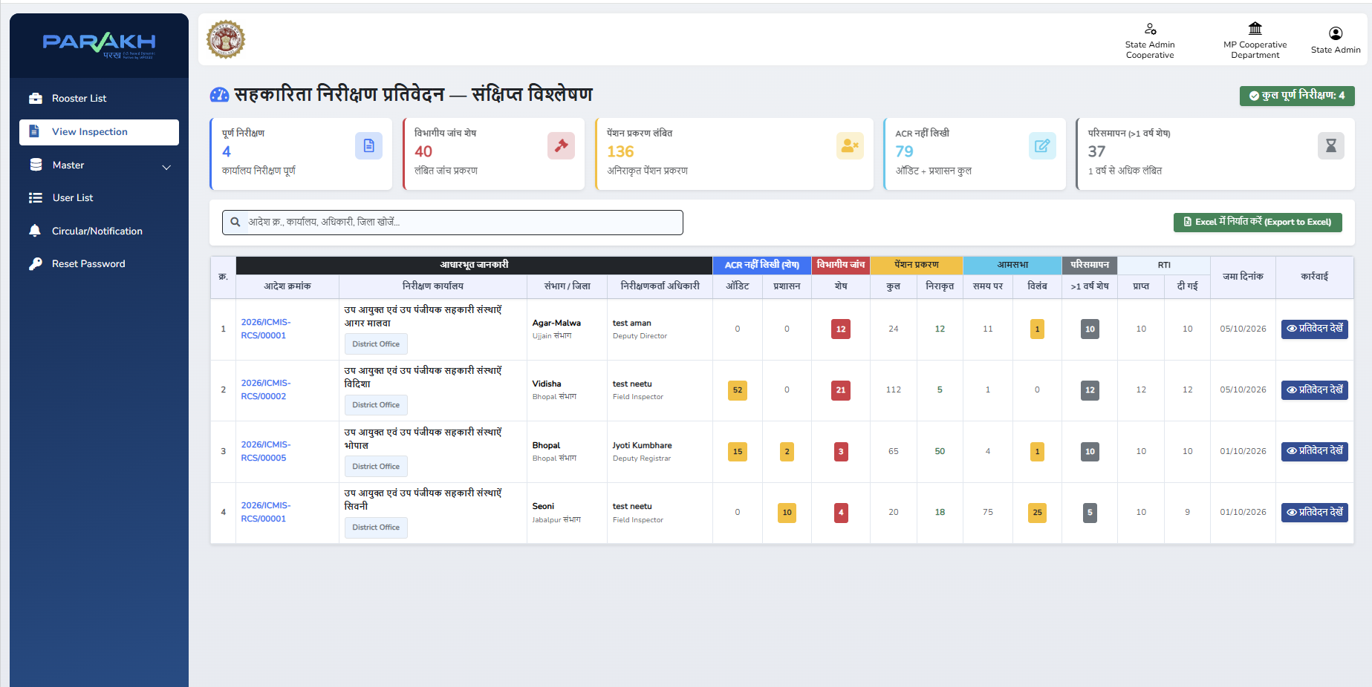
Summary analysis of completed inspections (pending departmental inquiries, pension cases, ACR, general meetings, liquidation, RTI) with search, Excel export and “View Report” per office.

7.2 Illustrative Report, Status and API Layout
The table below illustrates the Admin Report columns (downloadable in Excel and PDF) for the annual inspection roster:
Sr. | Inspecting Officer Name & Designation | Allotted Divisional Office | Allotted District Office | Current Status | Pending Days
1 | Sample Officer, Joint Commissioner | Sample Division Office | Sample District Office | Not Started / In Progress / Completed / Overdue | From order date

Inspection status lifecycle used across the dashboards:
Status | Trigger | Actor / Output
Order Issued | Roster eSign & Schedule completed | Commissioner; signed order PDF dispatched to surveyors
In Progress | Surveyor starts inspection / opens Fill | Surveyor; start date/time logged; drafts saved
Completed | Final Submit and e-Sign of report | Surveyor; signed report PDF; Commissioner / Nodal Officer notified
Overdue | Deadline passed and report not completed (daily batch) | System; red flag on dashboard; email alert

Illustrative payload for sharing a signed inspection report with ICMIS:
Parameter | Type | Description
officer_id | String | Unique ID of the inspecting officer
officer_name | String | Name of the inspecting officer
designation | String | Designation from Designation Master
office_id | String | ID of the inspected office (Office Master)
user_id | String | Parakh/ICMIS user ID of the officer
report_pdf | Base64 / File | Signed inspection report in PDF format
(additional) | – | To be added after discussion with the ICMIS team
Note: Field names, data types and authentication method are illustrative and will be finalized with the ICMIS integration team.

8. Methodology & Approach
The work builds on the Parakh inspection screens already available in UAT and the ICMIS portal, and is delivered in the following phases:
- Requirement Confirmation — confirm the requirement note, BSD, updated form and rules with the RCS IT Section (BRD update).
- Design — ICMIS-aligned UI design, role/eligibility model, workflow and status model, MP eSign flow and API contract.
- Development — in the workflow sequence of Section 4: masters, login, user list, roster and order, e-Sign, workflow, Nirikshan form, report view and dashboards, ICMIS API.
- Testing — unit, integration and regression testing by MPSeDC, including API testing with the ICMIS team.
- UAT — deployment to the UAT environment for Department sign-off.
- Go-Live — deployment to Production after UAT sign-off.

9. Deliverables
- Masters and user data loaded; bulk user creation.
- ICMIS-style login page with Department option only.
- Hierarchy-wise user listing (JR, DR, AR) with keyword search; Office Name in User Master.
- Annual roster and inspection order management with signed order and notifications.
- Custom e-Sign facility through MP eSign for orders and reports.
- Inspection workflow with status tracking, overdue alerts and corrigendum process.
- Nirikshan Prativedan form (section-wise tabs) with auto-fill, auto-calculation, draft save, preview and signed report PDF.
- View Inspection, dashboards, Excel / PDF reports and the Inspection Report tab in the ICMIS Departmental Login.
- ICMIS integration API with payload documentation.
- Updated BRD; UAT support and Department sign-off; Production deployment / Go-Live.

10. Project Timeline
The work is estimated for completion in 42 working days from the date of approval and receipt of confirmed masters and API details, as shown below:
Activity | Duration | Status / Target
Requirement finalization & Design (BRD update) | 4 days | Day 1–4 from approval
Development (SOW-01 to SOW-09, in workflow sequence) | 24 days | Day 5–28
Internal / Unit testing & API testing | 6 days | Day 29–34
UAT deployment & Department UAT | 6 days | Day 35–40
Production Go-Live | 2 days | Day 41–42
Total | 42 days | Go-Live: Day 42 from approval

11. Resource & Cost Estimate
This work is proposed to be billed on the man-day basis, at the rate of Rs. 12,000/- per man-day plus GST, consistent with the rate applied for earlier MPSeDC portal work. The man-day estimate below is indicative and subject to the Department’s approval; actual billing shall be based on man-days utilized.
S.No. | Activity | Estimated Man-Days
1 | Requirement Analysis, BRD update & Design (BA) | 4
2 | Masters & user data preparation (SOW-01) | 3
3 | Login page in ICMIS format (SOW-02) | 2
4 | Hierarchy-wise user listing, search & Office Name in User Master (SOW-03) | 2
5 | Annual roster & inspection order management (SOW-04) | 6
6 | Custom e-Sign through MP eSign (SOW-05) | 6
7 | Inspection workflow, status tracking & notifications (SOW-06) | 5
8 | Nirikshan Prativedan form development (SOW-07) | 14
9 | Inspection report view, dashboards & Departmental Login tab (SOW-08) | 4
10 | ICMIS API integration (SOW-09) | 5
11 | Internal / Unit & API testing | 6
12 | UAT deployment & Department UAT support | 4
13 | Deployment & Go-Live support | 1
 | Total | 62

S.No. | Item | Amount (Rs.)
1 | Resource Cost (62 man-days × Rs. 12,000/-) | 7,44,000
2 | GST @ 18% | 1,33,920
 | Grand Total (Estimated) | 8,77,920
Note: Figures above are an illustrative estimate for the Department’s evaluation and approval. Final invoicing will reflect actual man-days consumed.

12. Payment Terms
- Payment shall be raised on completion and successful Go-Live of the module in Production.
- Billing shall be computed on actual man-days utilized at the approved rate of Rs. 12,000/- per man-day, plus GST as applicable.
- Any scope beyond Section 4 (SOW-01 to SOW-09) shall be treated as a new requirement with its own man-day estimate.

13. Assumptions & Constraints
- The work will be built on the existing Parakh platform and ICMIS portal architecture, database and hosting infrastructure — no new infrastructure is required.
- The Department will confirm the Office, Office Head and Designation masters and provide the Inspection Officer master (ICMIS / e-HRMS data) before development of dependent items.
- The ICMIS, eHRM and CJCMS teams will provide API specifications, test environments and credentials; access to the MP eSign (Hastakshar) Gateway will be made available for signing.
- The screens in Section 7.1 are UAT screens with test data; SOW-04 to SOW-09 are based on the BSD, the Department’s functionality sheet, UAT feedback and the updated form, and are subject to final confirmation in the updated BRD.
- The Department will provide timely review and UAT sign-off; any request beyond Section 4 will require a separate estimate.

14. Reference Documents
Document | Reference No. / Date
Business Specification Document – Nirikshan Module | BSD v1.0, May 2026
Approved final format of Nirikshan Form for MP Cooperative Society on Parakh | RCS IT Section email dated 30.07.2026
Updated Inspection Format and Master Data (RCS Office Master) | RCS IT Section email dated 10.09.2026
Updated Nirikshan Form and UAT change list | Nirikshan Formats dated 02.10.2026; “Before UAT” changes
Review and confirmation of masters for Inspection Module | MPSeDC email dated 09.09.2026
RCS Computerization Meeting – Inspection Module status | RCS email dated 17.09.2026; meeting on 18.09.2026
Department requirement note (Inspection Report, e-Sign, Login, User List, API) | MP Cooperative Requirements
Parakh UAT workflow screens (Roster, eSign, Assigned Inspection, Nirikshan form, View Inspection) | Section 7.1 of this document
Sample ICMIS UI designs for module development | ICMIS portal screenshots (4 images)
MoM of meeting on MP Cooperative changes | MPSeDC email dated 29.06.2026 (meeting 24.06.2026)

15. Contact Persons
From Office of the Registrar Cooperative Societies | From MPSeDC
IT Section, O/o Registrar Cooperative Societies, Madhya Pradesh  Assistant Commissioner, O/o Registrar Cooperative Societies | Shri Ajeet Pal Singh, Technology Management Consultant  Shri Divendra Kumar Ojha, Project Manager  Ms. Priya Sharma, IT Consultant  Shri Dheeraj Motiyani, Sr. Business Analyst  Shri Aman Mishra, Developer  Shri Manish Dadhore, Tester

